**Task#**

**Create a local Repository in Git and then push this repository and its contents in remote repository , Github.**

**Create a directory where you’ll create the repository**

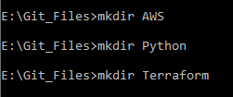

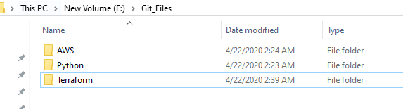



**Paste the files you need to push in that folder**

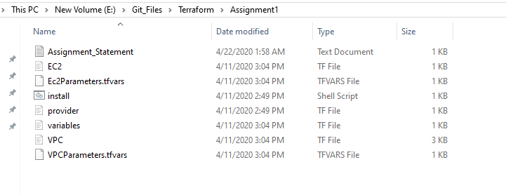

**Next initialize the repository by init command in git.**



**Now staging code**



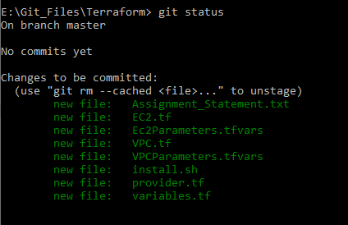

**Now committing code**

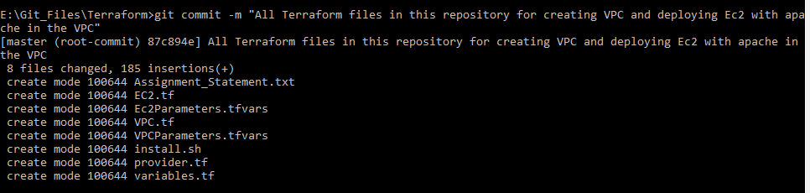

**Now check status**

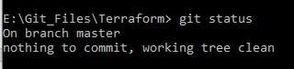

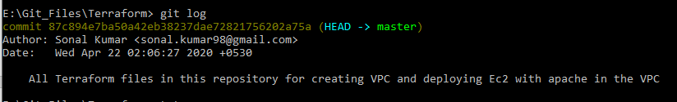

**Now create an empty repository in github**

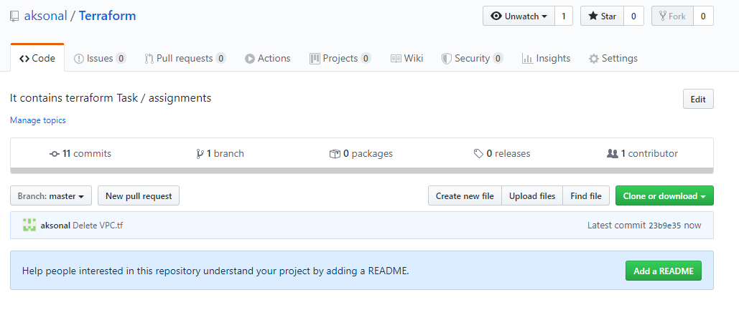

Now open the directory where your repository is located in git bash/ cmd



Now command to move it to remote repository

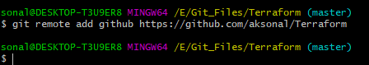

Verify the URL by below command

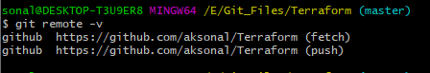

Now push changes through push command

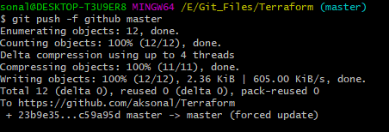

**Lets have a look at Github repository now**

